**BPL Match Analysis for Upcoming Season**

**BPL Data Set Info:**

Domain Name: Cricket

No. of Samples: 8960

No. of Category: 44

Unique Items: 4898

Data Set Size: 0.000599 GB

**Data Processing and Cleaning:**

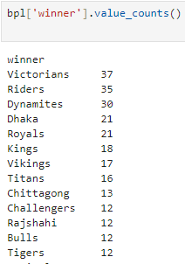

After cleaning unwanted data, we get

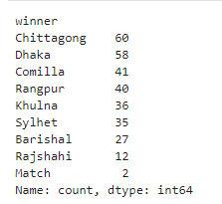

**Intelligent Questions:**

Question 1: How many matches a team wins that wins the toss?

|  |  |
| --- | --- |
| Team | Counts of Wins |
| Dhaka | 23 |
| Khulna | 19 |
| Comilla | 19 |
| Rangpur | 19 |
| Chittagong | 18 |
| Barisal | 15 |
| Sylhet | 15 |
| Rajshahi | 5 |

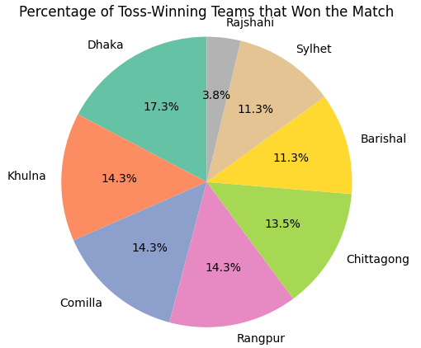

Question 2: How many matches did a team win when the team played in its own city?

|  |  |
| --- | --- |
| Team | Counts of Wins |
| Dhaka | 45 |
| Khulna | 2 |
| Comilla | 0 |
| Rangpur | 0 |
| Chittagong | 10 |
| Barisal | 0 |
| Sylhet | 0 |
| Rajshahi | 0 |

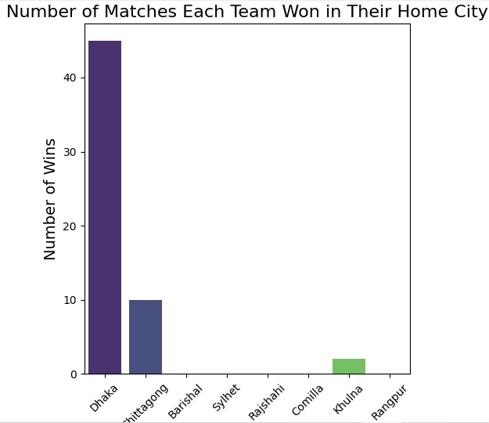

Question 3: What is the highest probability for a team to win upcoming match based on previous winning record?

|  |  |
| --- | --- |
| Team | Counts of Wins |
| Dhaka | 58 |
| Khulna | 36 |
| Comilla | 41 |
| Rangpur | 40 |
| Chittagong | 60 |
| Barisal | 27 |
| Sylhet | 35 |
| Rajshahi | 12 |

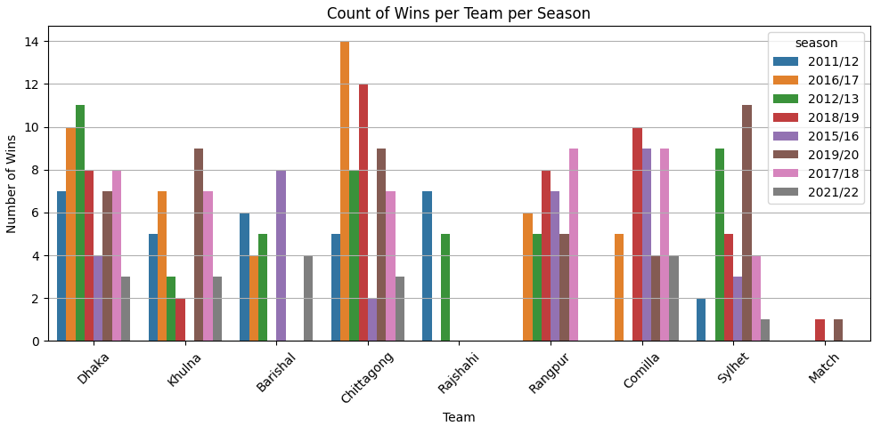

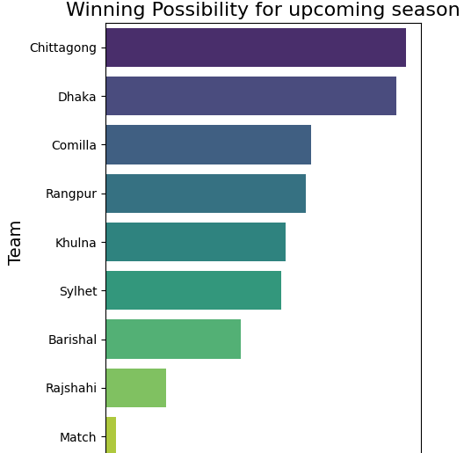

Question 4: How can team Dhaka win next match with other teams based on data set such as venue, toss winning, toss decision?

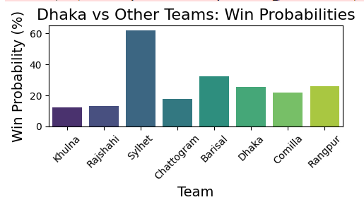

Question 5: Who is the best bowler based on wicket taken, economic rate and Maiden over to hire next season?

|  |  |  |  |  |
| --- | --- | --- | --- | --- |
| Player Name | Wicket | Economy | Maiden | Performance Score |
| Wahab Riaz | 5 | 2.18 | 1 | 0.792444 |

Question 6: Who is the best batsman to hire next season?

Question 7: Who is the most catch picker of all season?